Installing Docker for Windows

1. Go the link as follows: <https://www.docker.com/toolbox>
2. You will be greeted with the following screen, click “Download (Windows)”  
   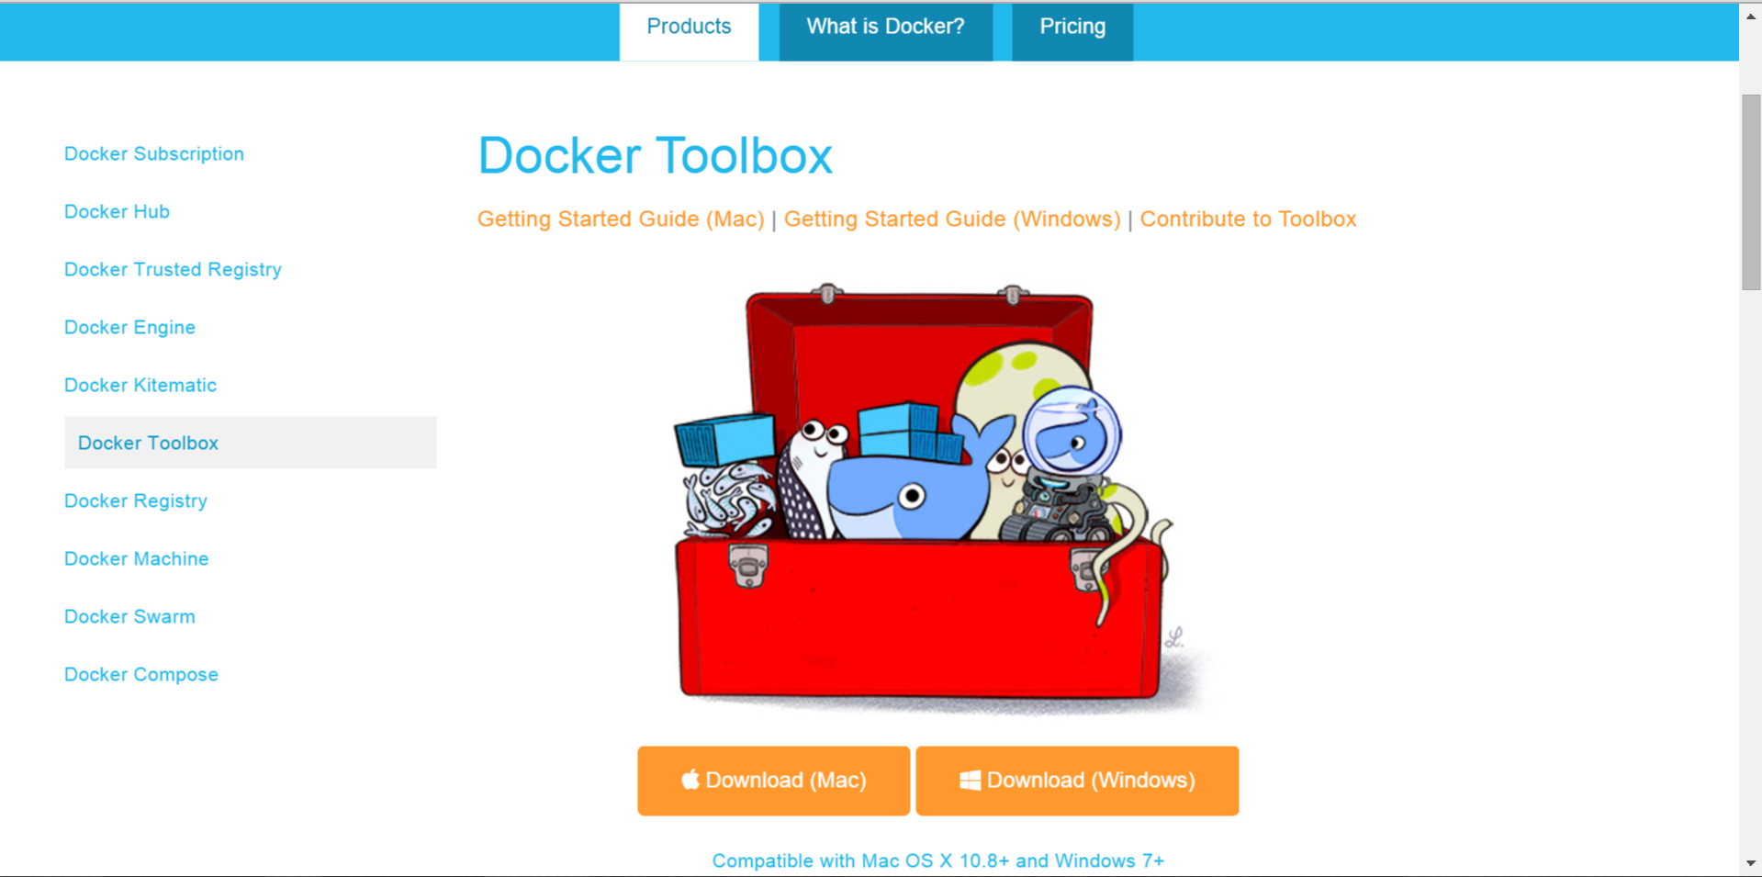
3. Click Next in the screen below  
   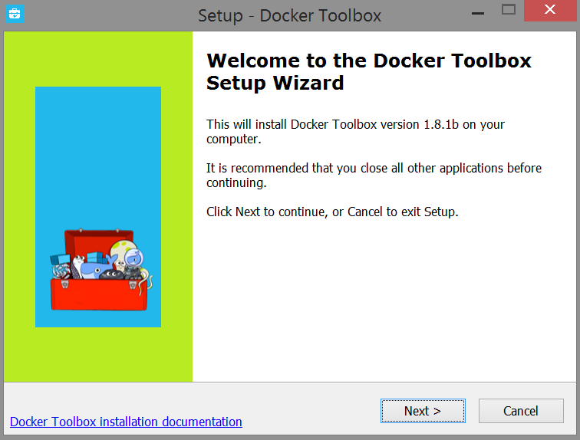
4. The screen will prompt you to set your installation directory. Click Next to continue.  
   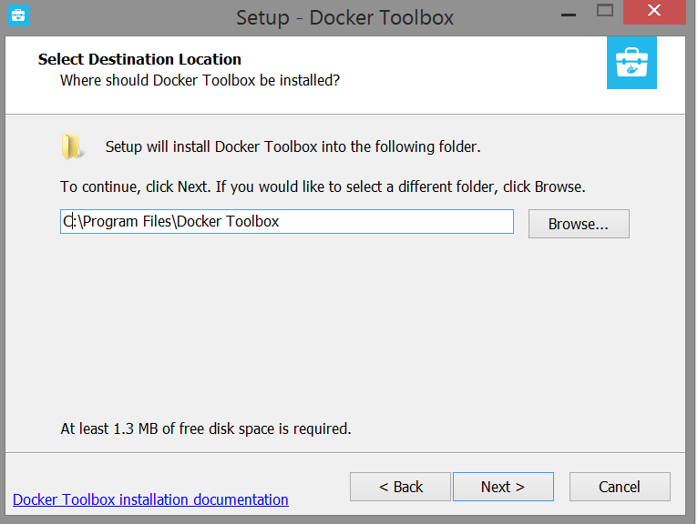
5. Make sure full installation is selected, and click Next.  
   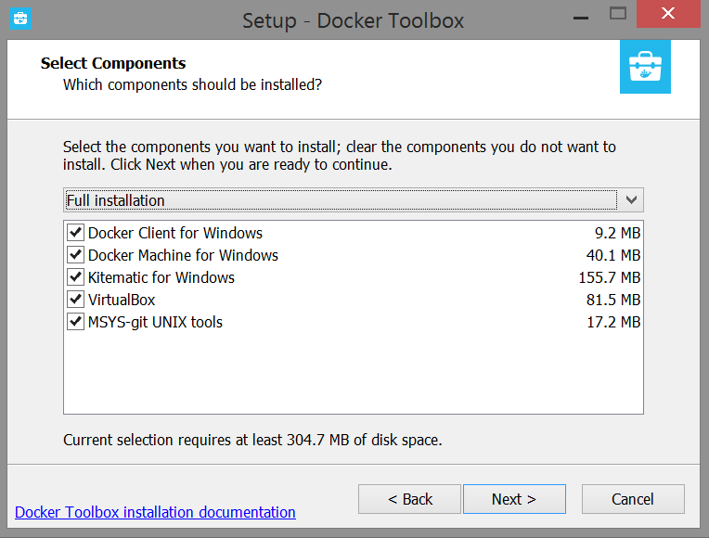
6. Make sure the options below are ticked, and click Next.  
   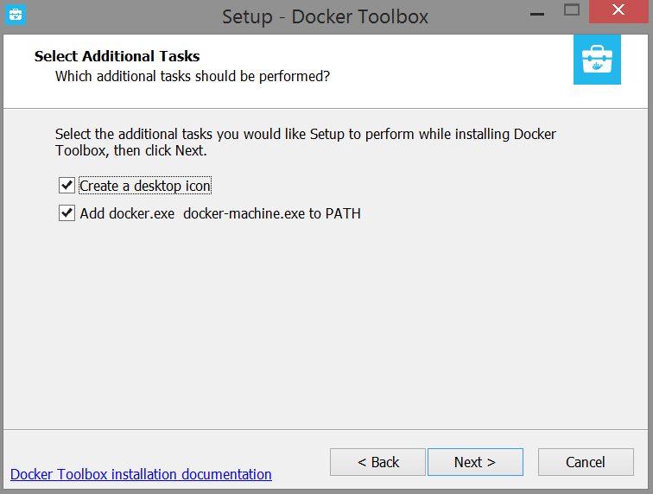
7. Click Install to begin installation.  
   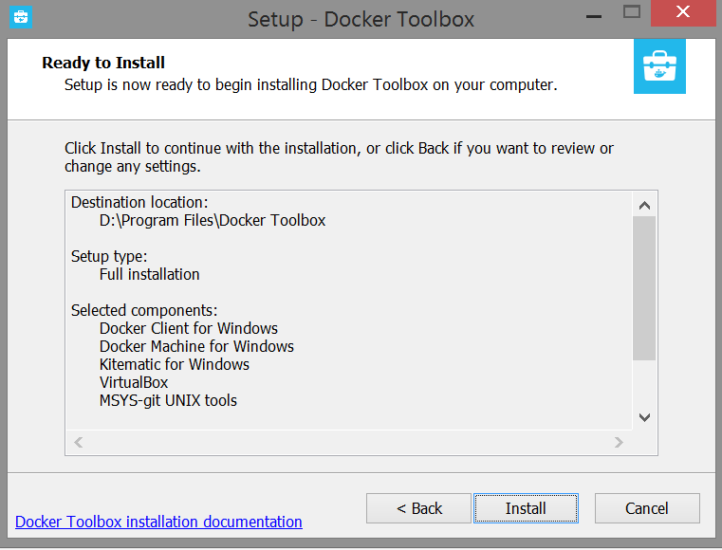
8. Finish the installation. Then double click on the “Docker Quickstart Terminal” icon below!  
   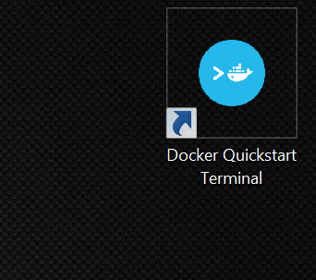
9. You should see this screen if installation is successful! If not, please contact a TA together with whatever is on the screen.  
   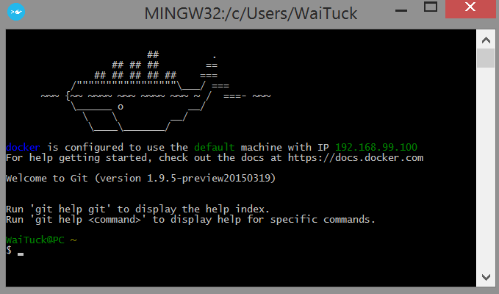
10. Check if docker is running properly by typing “docker run hello-world” without the quotes, as shown below.

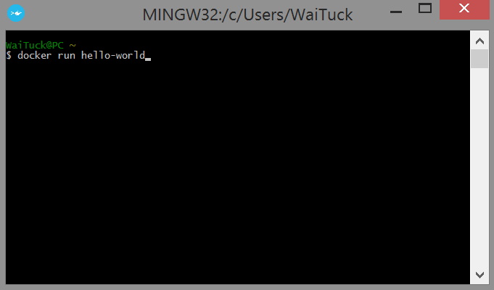

1. You should see the following (“Hello from Docker. This message shows that your installation appears to be working correctly.”) if your docker installation is working correctly. That’s it, you’re done!  
   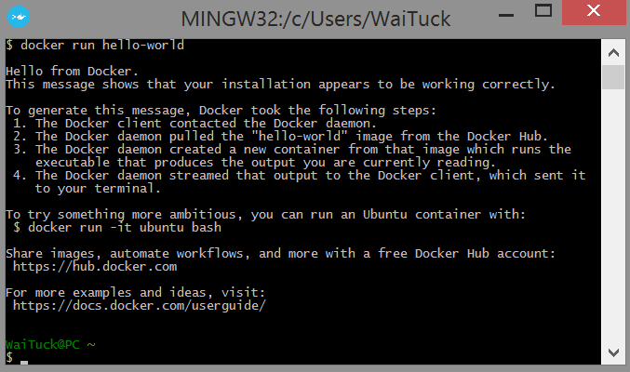

# TROUBLESHOOTING

1. It gets stuck at loading environment variables. Help!  
   A: Restart your computer and try again.
2. When I double click the Docker Quickstart Terminal, it tells me to press any key to continue, and shuts off after that. What do I do?  
   A: Uninstall VirtualBox (Add or Remove Programs -> Oracle VirtualBox) and reinstall VirtualBox by launching Kinematic (Alpha) from your desktop.